**Oracle Fusion Applications**

**APEX**

1. Request Workspace

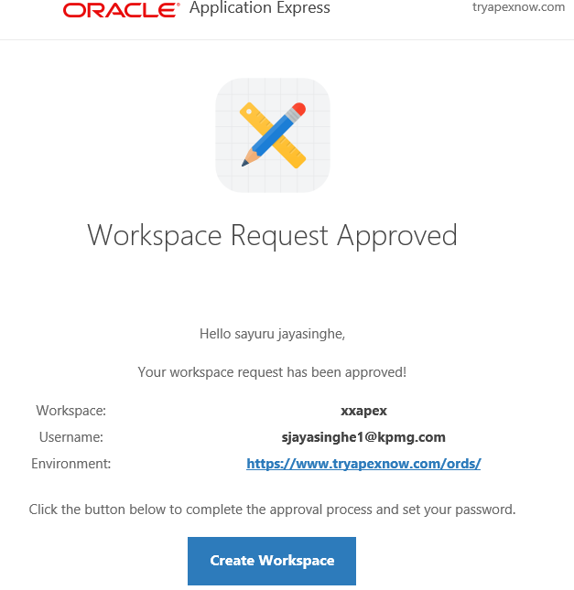

1. Create App

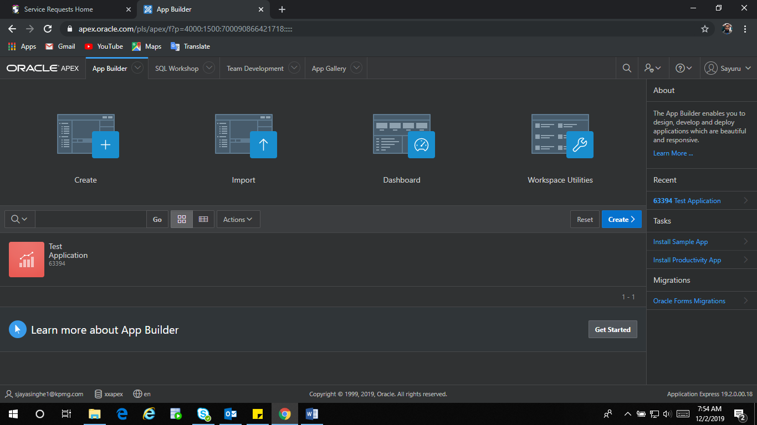

1. Legacy Web Service

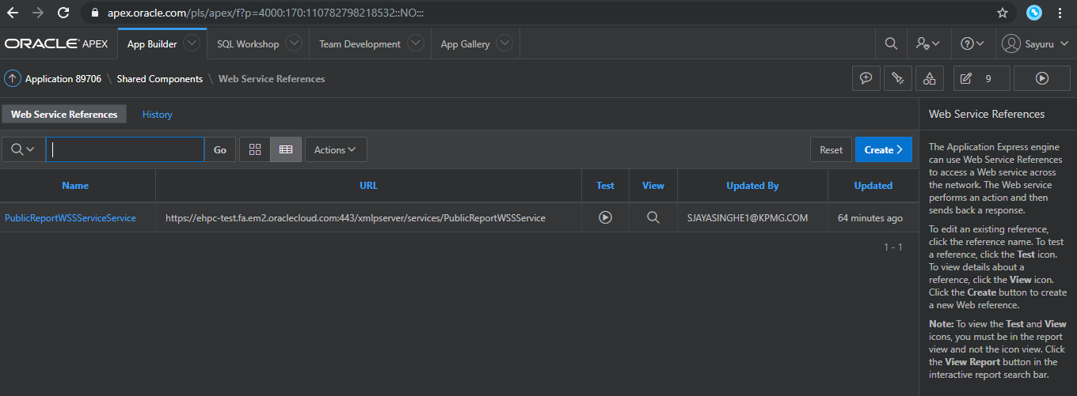

1. Test Web Reference

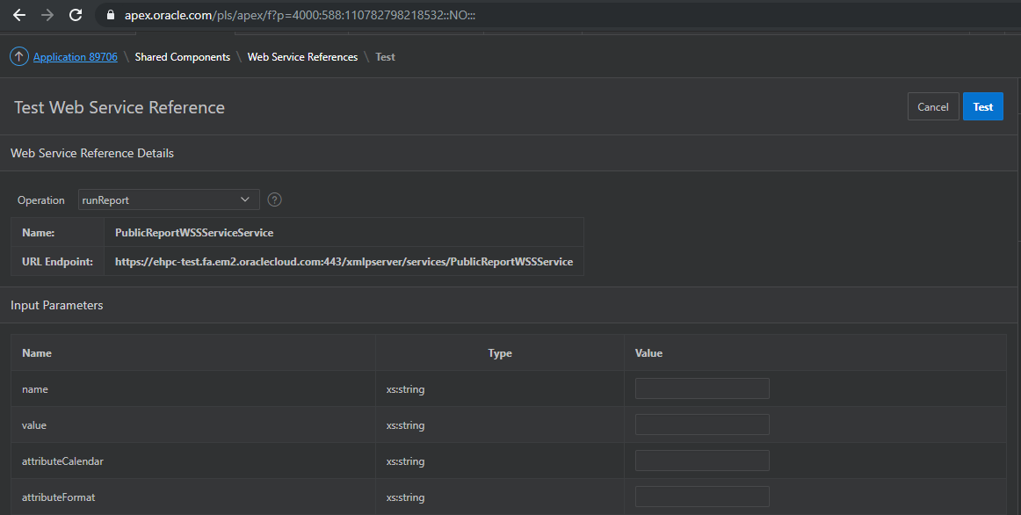

1. Test the web service and response

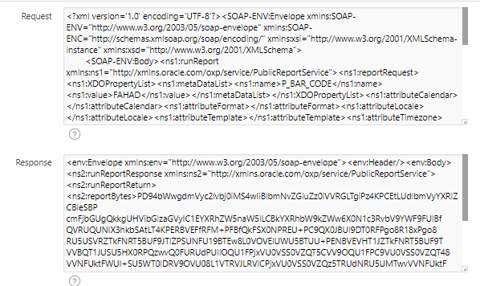

1. Created web application

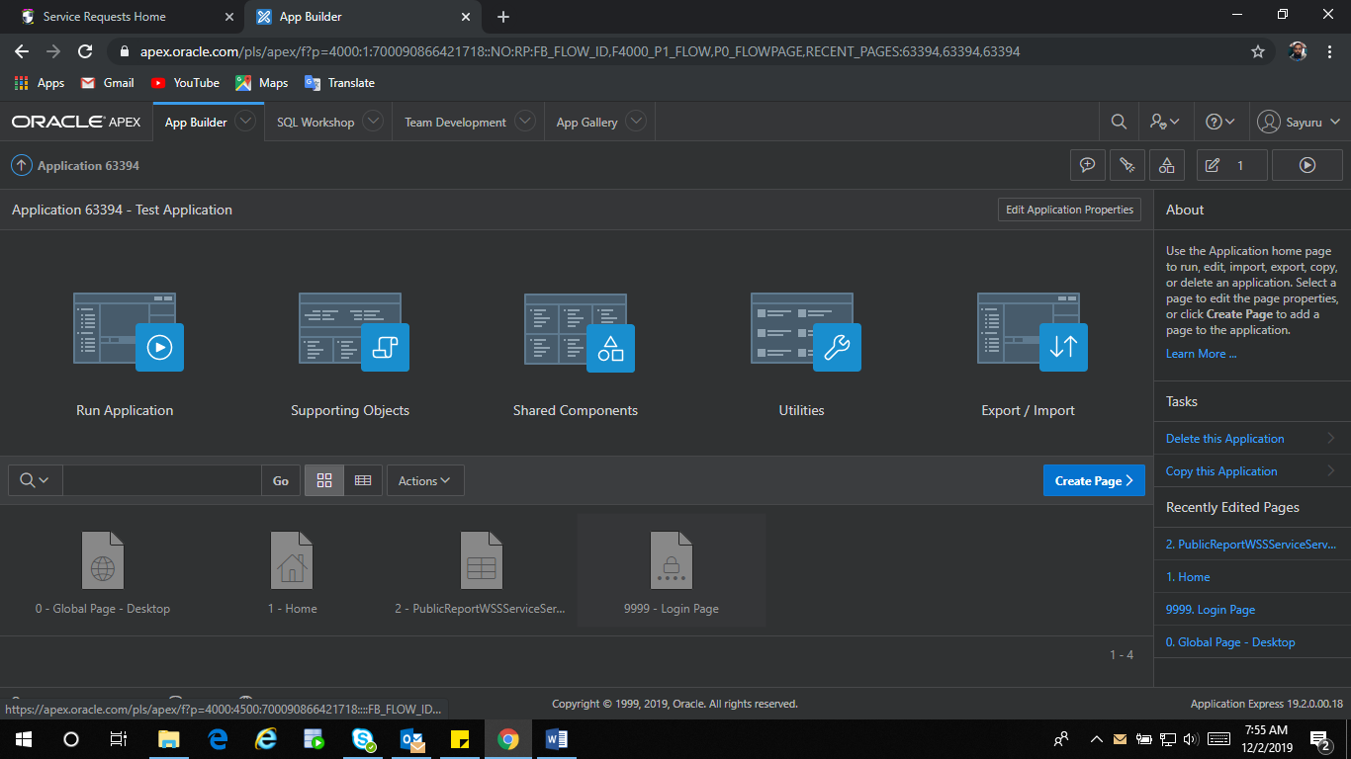

1. IDE view of the application

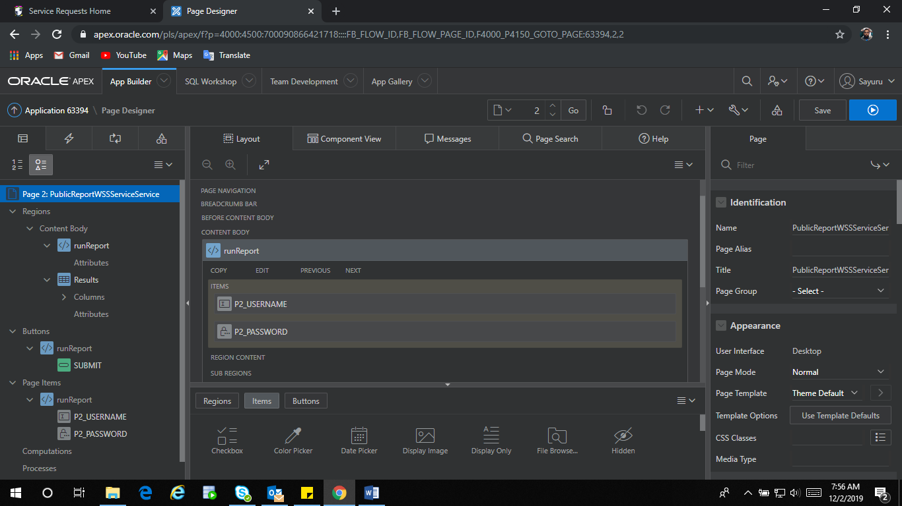

1. XML Parsing

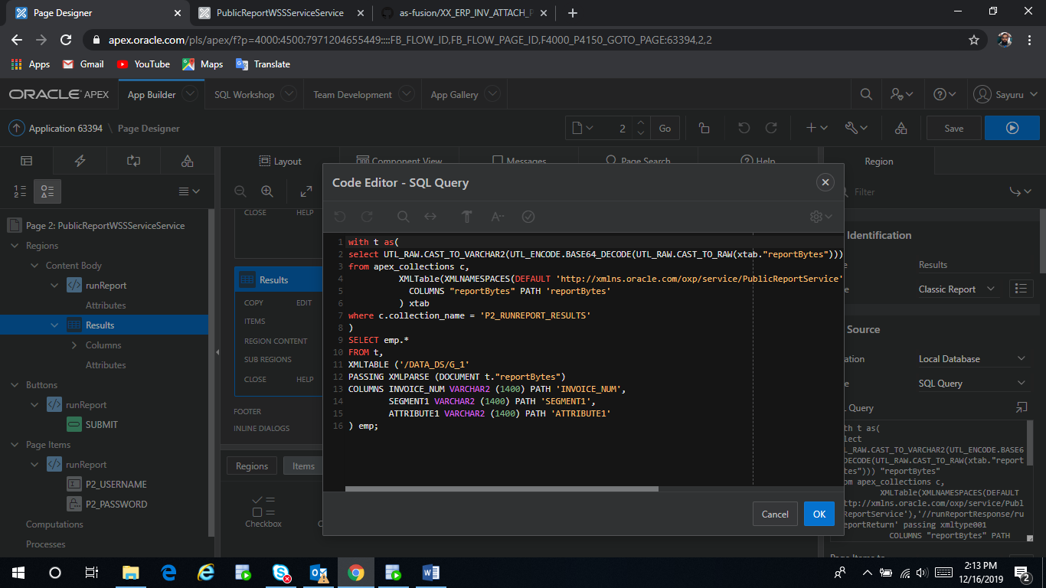

1. Login Page

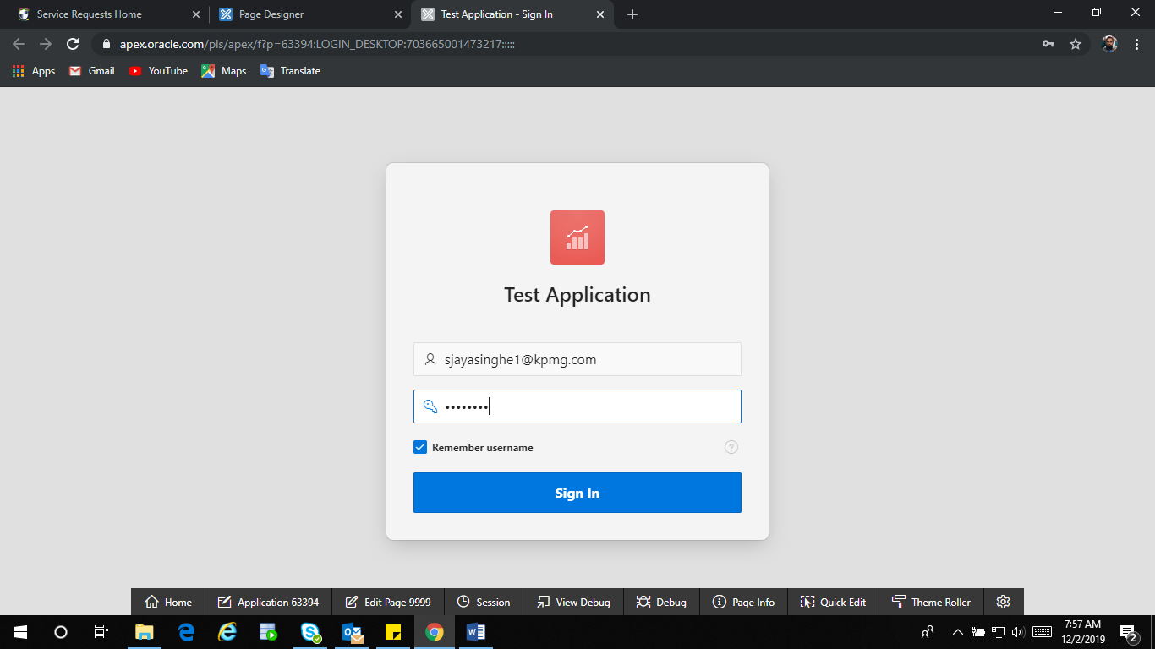

1. Application Page

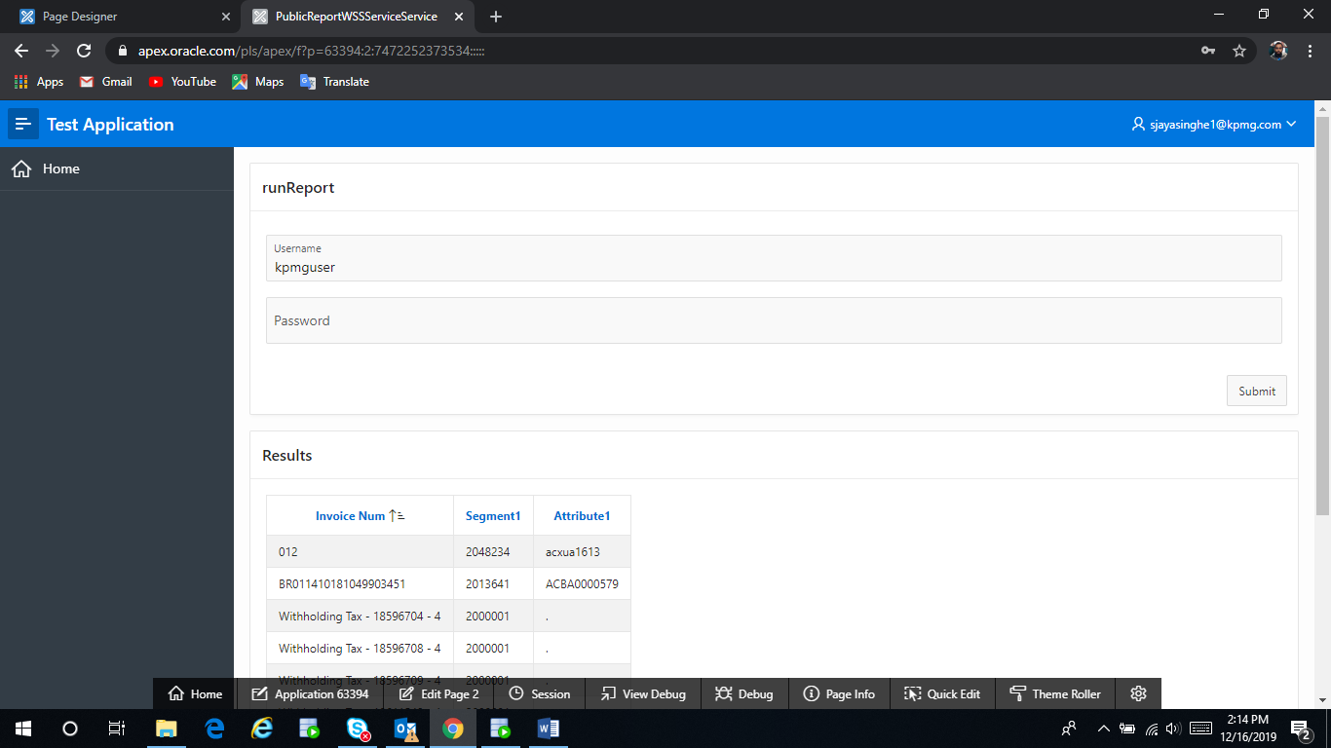

Q & A

* Using Oracle Application Express in Database Cloud Service (“<https://docs.oracle.com/en/cloud/paas/database-dbaas-cloud/csdbi/use-apex-this-service.html#GUID-B10AB0DA-94A4-4E2D-80BD-A755F923CA19>”)
* DB user and application user
* OAuth packages not the service for REST enabled services (“<https://docs.oracle.com/en/database/oracle/application-express/19.2/aeapi/OAUTH_AUTHENTICATE-Procedure-Signature-1.html#GUID-F6BADD65-416C-4B2F-8B19-BE98C64D5D83>”)
* SQL Workbench (SQL and Scripts)
* Zero or more repetitions in SOAP envelope – not able to use with standard wizard (Advance data types still not supported)
* Wallet not required